Bulk and Retail Petroleum

Module 3

Sections 1 to 17 of the Weights and Measures Regulations

January 2021

Uncontrolled copy for training purposes only

Table of contents
Section 2 4
Definitions 4
Section 3 5
Exemptions from the Act 5
Section 4 5
Exemptions from Section 8 and 15(1) of the Act 5
Section 6.1 6
Exemptions from Initial Examination and Dealer Responsibility for Examination 6
Section 7 6
Exemptions From Sections 8, 23 and 33 of the Act and Paragraph 24(b) of the Act: 6
Section 9 6
Section 12 6
Notice of Importation 6
Section 13 7
Specifications Relating to Approval 7
Section 14 and 16 7
Application for approval of a class, type or design of device 7
Section 17 8
Notice of Approval 8
Print a copy in PDF or HTML format of Sections 1 to 17 of the Weights and Measures Regulations (PDF)

Rationale

Section 2

Definitions
“acceptance limits of error” apply at the time:
- the device is evaluated for approval
- the device is examined before its first use in trade
- the measuring elements of the device are overhauled or repaired following the failure of the device on examination to measure within the applicable limits of error
- within 30 days after the time referred to in paragraph (b) or (c).

“examination mark” means a mark that indicates the year in which a device was examined. Previously referred to as “inspection mark”
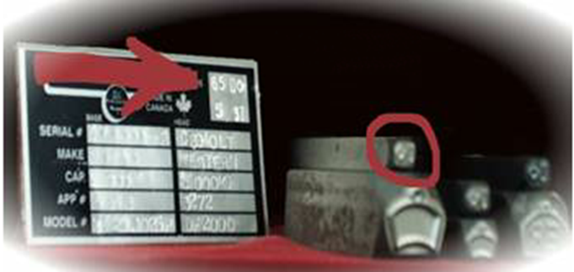
“examination sticker” means a self-adhesive label that indicates the month and year in which a device was examined and, if applicable, the month and year of the next examination required under section 15 of the Act, as determined in accordance with section 29. Previously referred to as “inspection sticker”
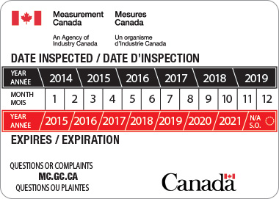

Section 3

Exemptions from the Act
- 3(1)a All devices that require examination under the Electricity and Gas Inspection Act are exempted from examination under the Weights and Measures Act and Regulations.
- 3(1)b All devices designed and used for scientific study and in laboratories are also exempted.
- 3(2)a) Tankers or tanks of 55,000 liters or above, that are used in the downstream oil trade, or to make the strapping capacity;
- 3(2)b) Instruments used to gauge the holds of ships used in wholesale trade of mining products

Section 4
Exemptions from Section 8 and 15(1) of the Act
(Approval, Initial examination and mandatory regulatory examination)
- Subsection 24(b)of the Act makes it an offence for any trader to possess or use in trade any device that does not measure within the limits of error prescribed. Traders who use devices that are exempted from approval and examination under Section 4 of the Regulations are in violation of Subsection 24(b) of the Act if the devices exceed prescribed limits of error. However, where no limits of error have been prescribed for a particular class or type of device, no examination of the device may be performed to determine compliance with Subsection 24(b) of the Act.
- Future regulatory initiatives will establish limits of error for exempted devices to ensure that these devices maintain minimum standards of accuracy and performance.
- In the interim, in the case of a complaint from a consumer, existing limits of error may be applied when examining the following devices:
- coin-operated machines for weighing persons;
- milk measuring tanks for farm use;
- measuring tanks mounted on railway cars; and
- tanks that have a capacity in excess of 55 000 litres or 12 000 gallons.

Limits of error set out in Schedule II of the Regulations may continue to be used when examining commodities provided on the basis of measure, even if the device used in the trade transaction is exempted under Section 4 of the Regulations and no limits of error are prescribed for that device.

Section 6.1

Exemptions from Initial Examination and Dealer Responsibility for Examination
- Registers including replacement registers on volumetric liquid meters do not require initial examination if the register does not incorporate automatic temperature, pressure, or density compensation.
- A register or replacement register (or one which has been altered to incorporate automatic temperature, pressure, or density compensation and is intended to have its function(s) operating) requires approval and examination prior to use in trade.
- A register that incorporates automatic temperature, pressure, or density compensation but does not have the function(s) turned on will not require an examination until such time as the functions are intended to be turned on.

Review Bulletin V-8

Section 7

Exemptions From Sections 8, 23 and 33 of the Act and Paragraph 24(b) of the Act:
- Approval,
- Examination,
- Annotated Restricted Use, and
- Measurement Within Limits of Error

- In particular circumstances when an approved device is unavailable or it would be impractical or unreasonably expensive to obtain approval, Section 7 can exempt devices from approval and examination with written consent of the Minister. In fact, under these circumstances the parties to the intended trade transaction can set their own limits of error (LOE) applicable to the intended device.

- Unusual circumstances between two companies and the Minister.

Section 9
Under Section 9, devices that were designed, approved and examination to measure in terms of one set of units is altered to measure in another authorized unit does not require a new approval if the device meets established requirements.
- Imperial conversion to Metric

Section 12

Notice of Importation
- Except for those devices exempted in section 4 of the Regulations (water, taxi meters, etc.), subsection 26(2) of the Act makes it an offence for dealers and traders to import devices without reporting the adjacent information as prescribed.

Section 13

Specifications Relating to Approval
- Section 13 grants the Minister (or his delegates) the authority to establish specifications for
- Non-Automatic Weighing Devices
- SGM Series
- SVM Series

Section 14 and 16

Application for approval of a class, type or design of device
Applications are available from the Measurement Canada web site or at a Measurement Canada district office.
Any company or individual may apply for approval provided the applicant can meet the requirements prescribed for the submission of samples, technical information, test data and other materials.
Approval examinations and all related testing are usually carried out within the facilities of Measurement Canada’s laboratories in Ottawa. In some cases, however, difficulties in transporting a device, the need for more specialized facilities and testing equipment or other factors may require other arrangements.
It is important to note that approvals take effect only when authorized on behalf of the Minister or the Director, and no Measurement Canada officer or other person can make any prior commitment respecting any approval.
Temporary approvals may be granted without a full range of laboratory testing where, for example, development of a new or modified type of device requires in-service use for a limited time.
Other forms of special approval may also be considered on an ad hoc basis in exceptional circumstances where, for example, a single device is to be put into service in a unique installation.
For those devices that can be evaluated in the laboratories, section 16 grants the Minister authority to request a number of device prototypes for evaluation along with the submission of samples, technical information, test data and other materials.

Section 17

Notice of Approval
- With the introduction of class approvals, manufacturers who previously had at least one full or conditionally approved device can now apply for class approval in one or more of the five respective classes listed:

- A vehicle scale used for static weighing
- A railway scale used for static weighing
- A tank or hopper scale used for static weighing where any dimensional size exceeds 1.6 meters or with a design capacity greater than 10,000 kilograms
- A platform scale with a load receiving element size exceeding 1.6 meters by 1.6 meters or a design capacity exceeding 10,000 kilograms used for static weighing
- Other large capacity weighing devices used for static weighing where any dimensional size exceeds 1.6 meters or the design capacity exceeds 10,000 kilograms.

The approval for each of these classes of large weighing devices applies only to the load receiving element. A primary weight indicator used with a large weighing device which is class approved must be approved separately by the Measurement Canada Laboratories.

- Once the approval examination is complete, a report, often in the form of a draft notice, is sent by the laboratories to the branch’s Approvals Committee and a copy is simultaneously sent to the applicant. If the committee concurs with the submission, it advises the Minister, the director or their delegate. Provided the delegate is also in agreement, the notice of approval is then issued. The approval will contain the information prescribed in Section 17.

